RUN THE APPLICATION

Open the anaconda prompt from the start menu. Navigatetothefolderwhereyourapp.pyresides. Nowtypethe “pythonapp.py” command.

Copy that localhost URL andopenthat URL in thebrowser. Itdoes navigatetowhereyoucanviewyourwebpage.

  **on**

the web page.



Thenitwil runonlocalhost:5000

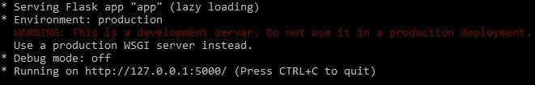

ateto t e o o

tt 0

e ou ew our eb page.

Clickonclassifybuttontoseetheresults.

 

